Student Name: _________________________________ Date: ___________

Instructor Signature:_________________________________ Date: ___________

Point Assignment: ________________________

Purpose: To introduce the student to the concept of inductive and capacitive reactance in AC circuits.

SAFETY CAUTION: This laboratory requires 120V in all experiments. You should treat this voltage level respectfully. Never handle a conductor terminal with 120V exposed. Do not lean on the equipment. Do not remove a conductor unless power is removed from the LabVolt unit through the proper disconnect. Do not perform any type of wiring connection to the circuit unless power is removed from the LabVolt unit. Always verify that power is off by observation and measurement. Students must always have supervision from an experienced instructor or laboratory technician when working with the LabVOLT equipment.

Background: Inductors and capacitors are energy storage devices used in electrical circuits. The inductor stores energy in the form of a magnetic field, whereas the capacitor stores energy via the electrostatic field between the capacitor plates.

In DC circuits, when energy is applied to the circuit, the energy storage device opposes a change in energy state; however, the energy gradually accumulates to a final steady state value. The energy that is stored in either type of device remains until the circuit conditions are altered enabling the circuit to release the stored energy.

In AC circuits, on the other hand, the energy source is continually changing between a positive and negative direction, causing the energy storage device to store energy during a change in one half cycle and release the energy during a change in another half cycle. During both the energy storage cycle and the energy release cycle, the device opposes the change in energy state. This opposition to a change in energy is referred to as reactance.

In AC circuit analysis, reactance models the voltage-current relationship for the storage device, similar to resistance, and has the units of Ohms, Ω. Two significant differences between reactance and resistance are (1) reactance is frequency dependent and (2) reactance has a phase angle of +90º, depending on the type of device. The reactance of an inductor can be calculated from the equation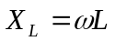, whereas the reactance of a capacitor is found from the equation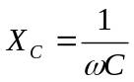. Another method for calculating the reactance of a device is to simply use Ohm’s law, V=IX_{L} or V=IX_{C}. Power for a reactive device can be calculated from the product of the voltage across the device and the current flowing through the device, Q=VI. This power can also be calculated from
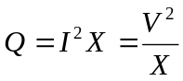 . This power is called the reactive power, which differs from average power. The average power for a reactive device is zero, since the energy is continually stored and released by the device without ever consuming the energy. The units for reactive power is Volt-
Ampere-Reactive, or VAR.

Procedure: 1. (10%) Identify three values of capacitance to be used in this
experiment, 2.2μF,4.4μF, and 8.8μF.
- For a 120V_{RMS}, 60Hz power source, compute the reactance of each capacitor value, .
Table1(a): Capacitive Reactance Calculations
Capacitor | Reactance, X_{C} (Ω)
2.2μF
4.4μF
8.8μF

- If each capacitor is connected individually to the 120V_{RMS} voltage source, compute the current that will flow in each case, 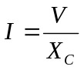.

Table1(b): Capacitive Current Calculations
Capacitor | Current, I (A)
2.2μF
4.4μF
8.8μF

- Compute the reactive power that will flow as a result of the device reactance using the formula, Q=-VI.

Table 1(c): Capacitive Power Calculations
Capacitor | Power, Q (VAR)
2.2μF
4.4μF
8.8μF

C
I
120 V_{RMS}
60Hz
Figure #1: Capacitor Circuit

- (10%) Equipment required: Variable AC power supply, Wattmeter, AC Ammeter, AC Voltmeter, and Capacitor load bank.
  - Set the supply voltage to 120V_{RMS}. Turn off the power.
  - Connect the source, watt meter, AC ammeter, AC voltmeter, and capacitor load bank as shown. Note: make sure all the capacitor toggle switches are open.
  - Close the toggle switch to one of the capacitors. Turn on the power source. Record the measured voltage, current, and power displayed on the meters. Turn off the power source. (Note that the average power to the capacitor should be near zero. This value is typically small enough to be neglected.)
  - Using the measured voltage and current value, compute the reactance. X_{C}=V/I.
  - Repeat steps a-c for each capacitor. Note: be sure to open the toggle switches for the capacitors that are not being used.

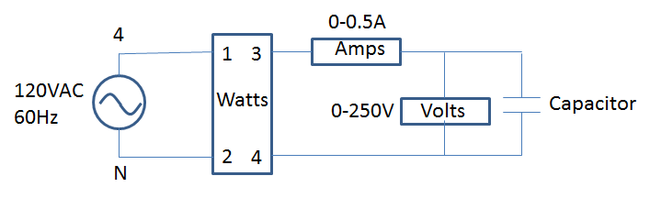
Figure #2: Capacitor Measuring Circuit

Table 2: Capacitor Measurements and Calculations

Capacitor | Voltage  Volts | Current  Amps | Power  Watts | Calc. Power S=VI | Reactance  X_{C}=V/I
2.2μF
4.4μF
8.8μF

3. (10%) Identify three values of inductance to be used in this experiment, 0.8H, 1.6H, and 3.2H.
- For a 120V_{RMS}, 60Hz power source, compute the reactance of each Inductor value, .

Table 3(a): Inductive Reactance Calculations
Inductor | Reactance, X_{L}
0.8H
1.6H
3.2H

- If each inductor is connected individually to the 120V_{RMS} voltage source, compute the current that will flow in each case, 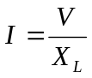.
Table 3(b): Inductive Current Calculations
Inductor | Current, I
0.8H
1.6H
3.2H

- Compute the reactive power that will flow as a result of the device reactance using the formula, Q=VI.

Table 3(c): Inductive Power Calculations
Inductor | Power, Q
0.8H
1.6H
3.2H

L
120 V_{RMS}
60Hz
I
Figure 3: Inductor Circuit

- (10%) Equipment required: Variable AC power supply, Wattmeter, AC Ammeter, AC Voltmeter, and Inductor Load bank.
  - Set the supply voltage to 120V_{RMS}. Turn off the power.
  - Connect the source, watt meter, AC ammeter, AC voltmeter, and inductor load bank as shown. Note: make sure all the inductor toggle switches are open.
  - Close the toggle switch to one of the inductors. Turn on the power source. Record the measured voltage, current, and power displayed on the meters. (Note that the average power to the inductor should be near zero. This value is typically small enough to be neglected.) Turn off the power supply.
  - Using the measured voltage and current value, compute the reactance. X_{L}=V/I.
  - Repeat steps a-c for each inductor. Note: be sure to open the inductor switches for the inductors that are not being used.
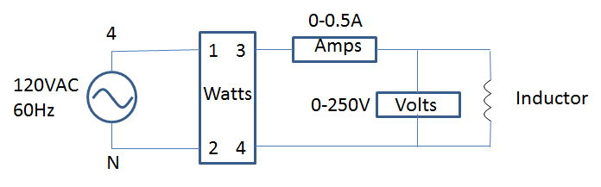
Figure #4: Inductor Circuit Measurement Circuit

Table 4: Inductor Circuit Measurements and Calculations
Inductor | Voltage, V | Current, I | Power, Q | Reactance, X_{L}
0.8H
1.6H
3.2H

- (10%) Build the circuit shown below in Multi-Sim. The capacitor value will remain fixed at 8.8 μF. Set the AC voltage source to 120V and vary the frequency as listed in Table 5 below. Measure the RMS current and record the current for each value of frequency.

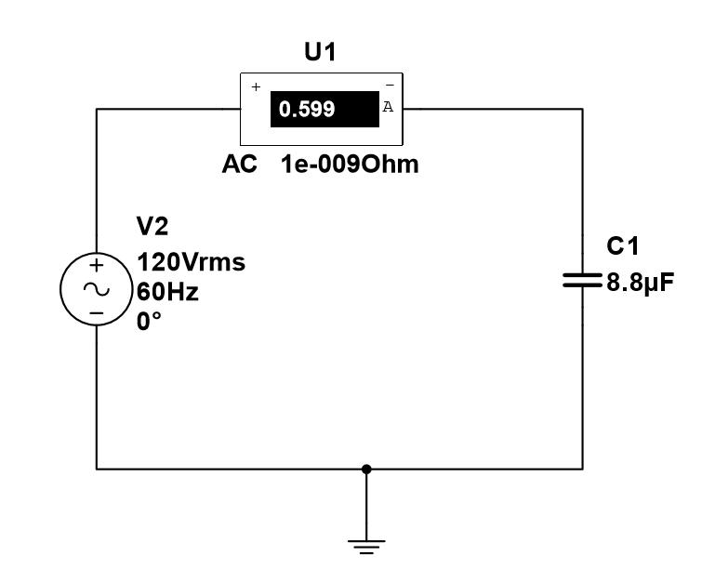
Figure #5: Frequency Variation for the Capacitor Circuit

Table 5: Capacitor Current versus Frequency Variations
Frequency (Hz) | Current (A)
0
30
60
90
120

- (10%) Build the circuit shown below in Multi-Sim. The inductor value will remain fixed at 800 mH. Set the AC voltage source to 120V and vary the frequency as listed in Table 6 below. Measure the RMS current and record the current for each value of frequency.

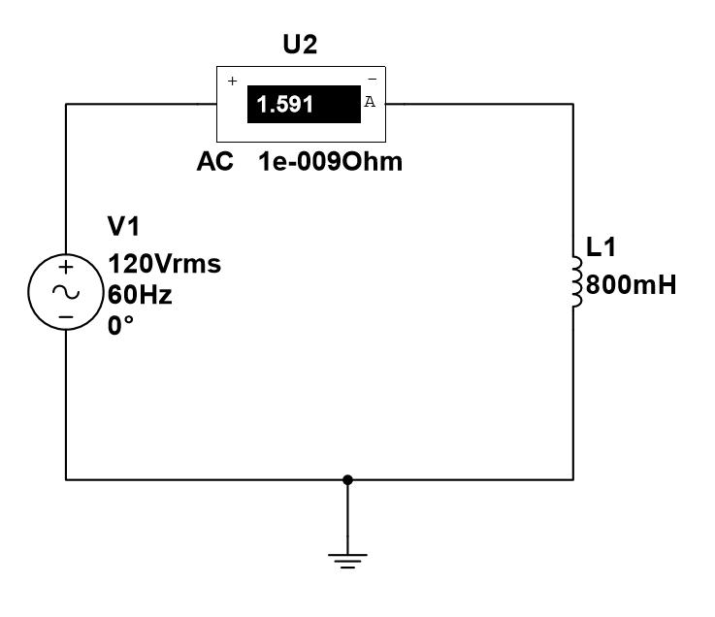
Figure #6: Frequency Variation for the Inductive Circuit

Table 6: Inductor Current versus Frequency Variations

Frequency (Hz) | Current (A)
0
30
60
90
120

Questions (40%):
- From Table 2, compare the capacitor value column with the capacitor current column. What pattern did you observe with the capacitor current as the capacitor value increased? Explain your observation using ohm’s law.

- From Table 2, compare the capacitor value column with the capacitive reactance column. What pattern did you observe with the capacitive reactance when the capacitor value increased? Explain your observation using the reactance formula, X=1/ωC.

- What would happen to the capacitor current if the capacitor value approached a value of zero? (Hint: use ohm’s law and the reactance formula to reason your answer.)

- From Table 4, compare the inductor value column with the inductor current column. What pattern did you observe with the inductor current as the inductor value increased? Explain your observation using ohm’s law.

- From Table 4, compare the inductor value column with the inductive reactance column. What pattern did you observe with the inductive reactance when the inductor value increased? Explain your observation using the reactance formula, X=ωL

- What would happen to the inductor current if the inductor value approached a value of zero? (Hint: use ohm’s law and the reactance formula to reason your answer.)

- From tables 5 and 6, what general conclusions or rules can you make about the capacitor’s and inductor’s predictive behavior in an electrical circuit due to frequency variations?

